Aina Paola D. Enriquez

2-ECE-B

**Programming Assignment Proofs**

**PANDAS**

*Problem 1*

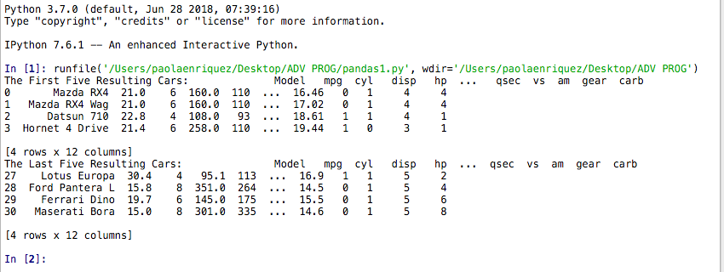

Figure 1 Run File

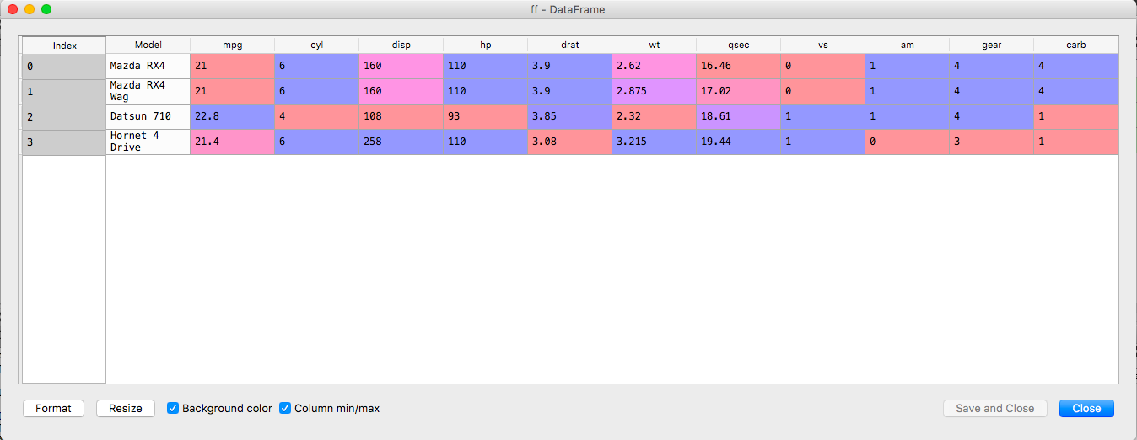

Figure 1.1b First Five Rows

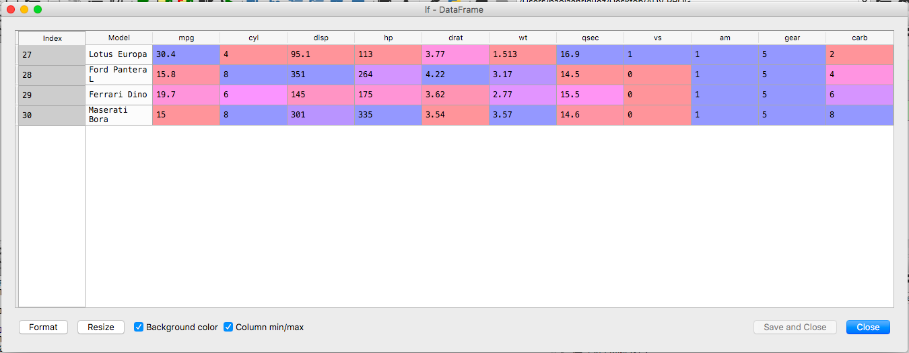

Figure 1.2b Last Five Rows

*Problem 2*

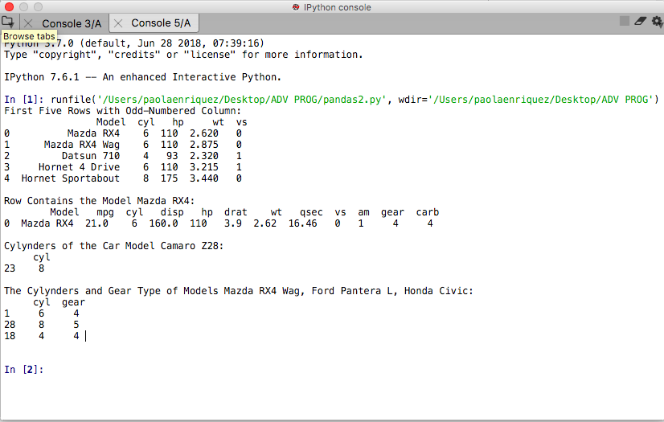

Figure 2 Run File

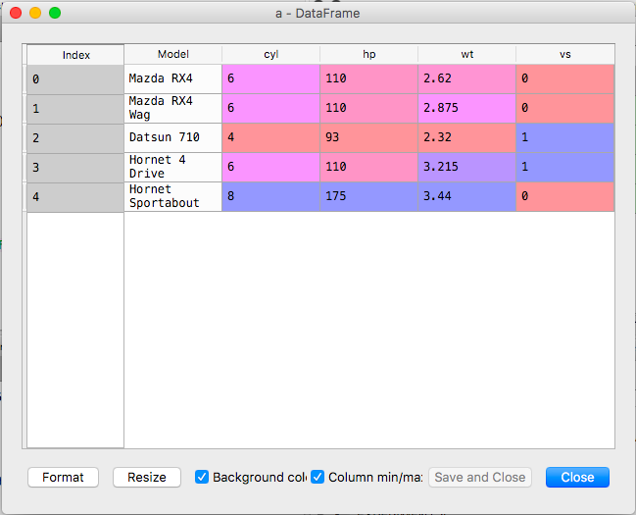

Figure 2a

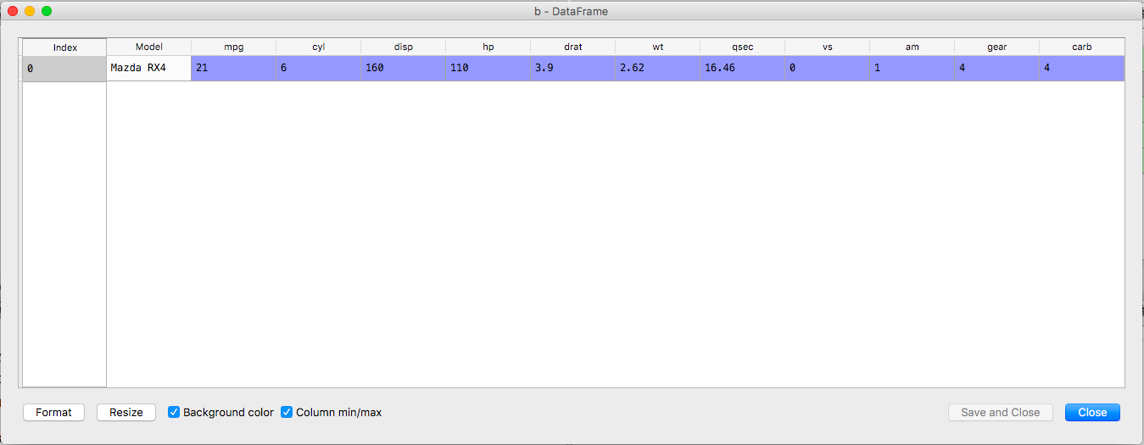

Figure 2b

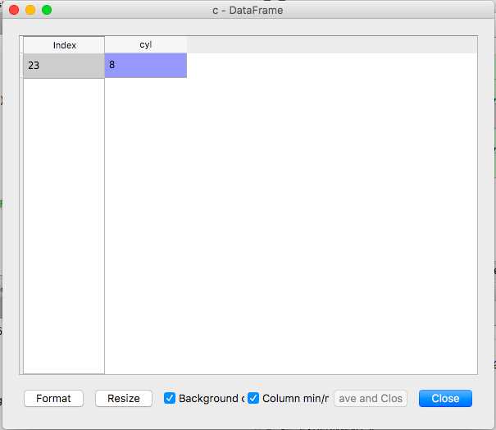

Figure 2c

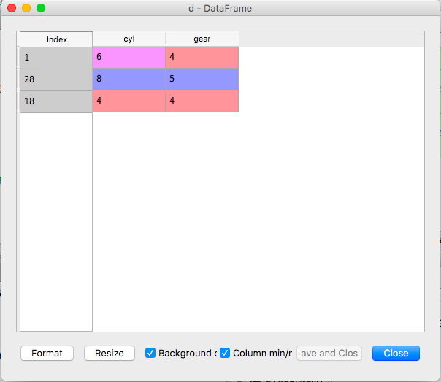

Figure 2d